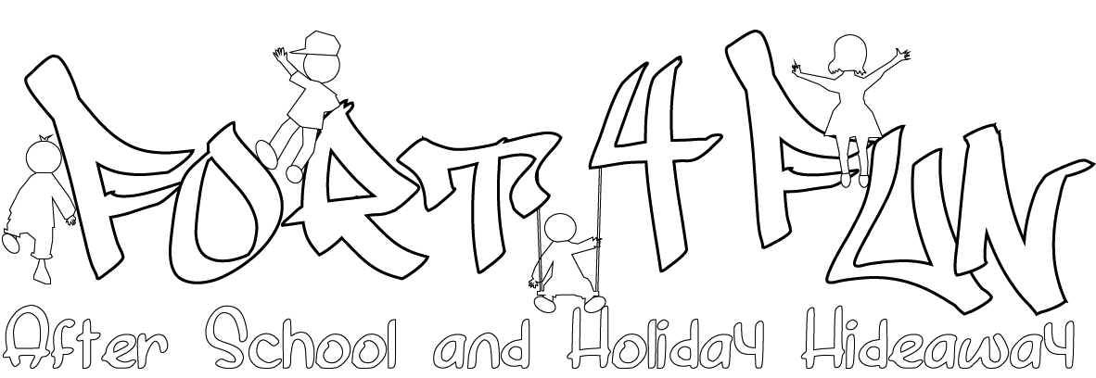

Fees per day

Receive a 10% discount for booking and paying a half term in advance!

After School Care (3.15pm – 6.30pm) | £11
After School Care if children attend a Melcombe school club (4.15pm – 6.30pm) | £8
After School Care per hour | £4
Holiday Hideaway (9am – 5pm) | £22
Holiday Hideaway (8am – 9am) | £2
Holiday Hideaway (5pm – 6.30pm) | £2
Emergency childcare | £15

Tea Time is at 4.30pm. All children who attend Fort 4 Fun at this time will be given a healthy, nutritious snack, which is included in the fee per day.

Discounts

After School Care

10% discount if you child attends 5 days a week

10% discount per sibling for after school care

10% discount for booking and paying a half term in advance

Holiday Hideaway

10% discount for early bookings and payment 2 weeks in advance

20% discount for the 1st sibling

10% discount for any siblings thereafter

Emergency Childcare

Fort4Fun is able to offer emergency childcare on an ad hoc basis. This can be booked in advance by emailing bookings@fort4fun.co.uk or calling 07949124904 stating the dates you require. If you find yourself stuck with very short notice please call and Fort4Fun will endeavour to help you as much as possible (this is dependant on staff:child ratios).

Payment

Payment for any sessions your child attends is due in advance, either termly, half termly or monthly via BACS or cash. Cheques are not accepted.

Fort4Fun is happy to sit down with parents and work out payments, as we understand everyone’s individual circumstances are different.

Tax Credits and Childcare Vouchers

Fort4Fun can provide parents with their OFSTED Registration number to enable them to claim for tax credits.

Fort4Fun is happy to accept childcare vouchers and can register with any childcare voucher scheme you employer uses.

Late Fees

At Fort4Fun we understand that things can go wrong unexpectedly and therefore we will give you one chance per term for any late collection.

If children are collected late a second time the charge is £20 per half hour. After 7pm we have a duty to contact social services.
If children are collected late persistently and prior late fees are not paid their places will be withdrawn immediately without a refund of any monies already paid.

Cancellation and Refunds

Should you wish to cancel your child’s place a full refund will be given only if Fort4Fun is given 2 weeks notice in writing prior to the your child’s start date.

If you wish to stop using Fort4Fun’s services a notice of 4 weeks is due in writing.

Upon enrolment all parents will receive a parent information pack that sets out our policies in full regarding fees, payment, cancellation and refunds.

