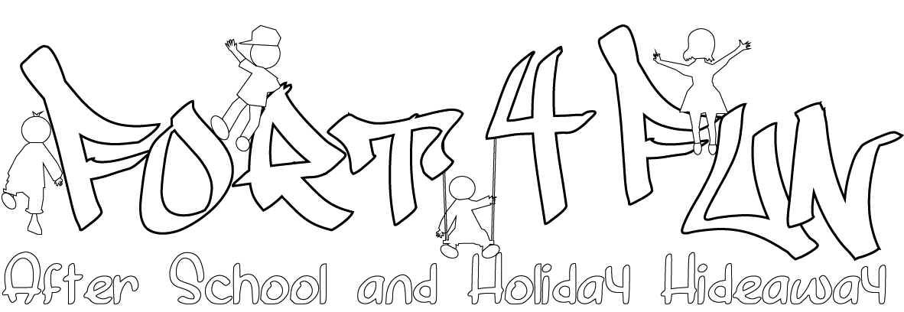

Emergency Childcare Booking Form

If you know there will be some dates in the future that you will require childcare, you can use our emergency childcare service. This means your child does not attend on a regular basis. This form must be completed and returned at least one week before the first date you require childcare. If it is less that one week before the date you need please call 07949124904 and we will try to help you as best as we can.
This is not guaranteed, please wait for a response from the manager to confirm childcare is available for your dates.

Complete the form below and e-mail it to bookings@fort4fun.co.uk or post it to Fort4Fun at the address below. You will be invoiced the total amount. Payment is due within 7 days.

Fees:

Emergency Childcare (3.15 - 6.30) - £15.00 per session

To cancel any pre booked dates we require 6 week’s notice to be entitled to any refund

Name of child(ren)
Address
Telephone
E-mail

Please list the dates below:

