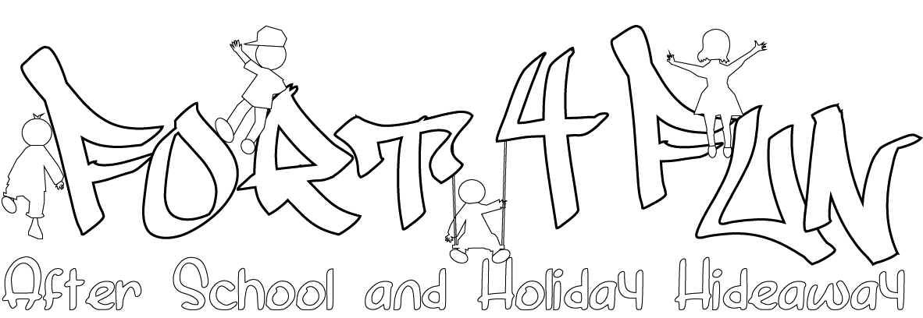
Yearly Booking Form

If you know which sessions you will need for the whole year we can work out a monthly amount for you, which can be paid directly from your bank account or by childcare vouchers (you will need to inform Fort4Fun of the scheme you use so that Fort4Fun can register with it).
This guarantees your child’s place at Fort4Fun until July 2016. Please note bookings for the Holiday hideaway are separate.

Only one booking form needs to be completed for the whole year.

Complete the form below and e-mail it to bookings@fort4fun.co.uk or post it to Fort4Fun at the address below. We will calculate your monthly payment in a payment plan and inform you by e-mail (if possible) or letter. You will be invoiced each month and all payments are due within 7 days to fit in with our policy of payment in advance.

Fees:

Term Time (3.15 - 6.30) - £11.00 per session/ £10 siblings / £10 if child attends 5 days

To cancel services we require 4 week’s notice otherwise you will be charged your monthly payment
- Administration charge of £5.00 will be made each time your payment plan is recalculated during the year
Name of child(ren)
& Age/s
Address
Telephone
E-mail

 | Monday | Tuesday | Wednesday | Thursday | Friday
Times
Required

Delete as appropriate

I would like to pay
half termly (10% discount)/ termly (10%discount) / monthly in advance

I would like to pay by BACs / Cash

